Machine Learning Project Report

Customer Churn Prediction using Logistic Regression and Random Forest

1. Introduction
Customer churn prediction is a critical task in the banking sector, where identifying customers likely to leave helps reduce financial loss. This project aims to predict customer churn using supervised machine learning techniques.
Two models were implemented and compared:
- Logistic Regression (Linear Model)
- Random Forest (Non-linear Ensemble Model)
The objective is to evaluate which model performs better in handling real-world imbalanced data.

2. Dataset Description
- Dataset: Customer Churn Dataset
- Size: 10,000 records
- Target Variable:
  - Exited = 1 (Churn)
  - Exited = 0 (Stay)

Class Distribution (From Output)
- Stayed: 7963 (≈80%)
- Churned: 2037 (≈20%)
👉 This indicates a class imbalance problem, which impacts model performance.

3. Data Preprocessing
The following preprocessing steps were applied:
- Removed non-informative features:
  - RowNumber, CustomerId, Surname
- Encoded categorical variables:
  - Geography, Gender
- Applied StandardScaler (for Logistic Regression)

Justification (Theory)
- Scaling is required for gradient-based models like Logistic Regression
- Removing identifiers prevents overfitting
- Encoding allows algorithms to process categorical data

4. Exploratory Data Analysis (EDA)
Exploratory Data Analysis (EDA) We visualize data to understand feature distributions and relationships before modeling:

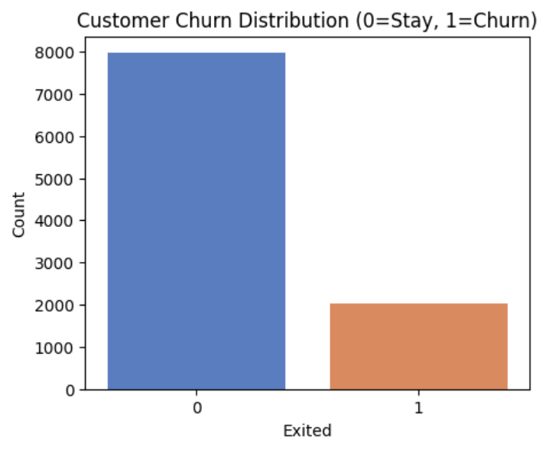
Churn (1) vs. Stay (0) counts: {0: 7963, 1: 2037}

Findings from Output
- Class Imbalance: Majority of customers did not churn
- Correlation: Age and Balance influence churn
- Distribution: Older customers show higher churn tendency
👉 These findings justify the need for balancing techniques

Model 1: Logistic Regression
5.1 Baseline Model Results
Baseline Model Classification Report:

Class | Precision | Recall | F1‑Score | Support
0 (Stay) | 0.804 | 0.966 | 0.878 | 1593
1 (Churn) | 0.379 | 0.081 | 0.134 | 407

The baseline Logistic Regression model was trained using the original Customer Churn dataset without handling class imbalance or applying any hyperparameter tuning. The model achieved an accuracy of 78.6%, which initially suggests good performance. However, this metric alone is misleading for churn prediction.
When examining class‑level performance, the model performs well for non‑churn customers (class 0) but poorly for churn customers (class 1). The recall for churners is only 0.081, and the F1‑score is 0.134, indicating that the model fails to identify most customers who actually leave the bank.
This behavior occurs because the dataset is highly imbalanced, with a much larger proportion of customers staying compared to those churning. As a result, the model becomes biased toward predicting the majority class. This leads to the accuracy paradox, where high accuracy does not translate to useful business performance.

Analysis of the Baseline Logistic Regression Model
In this dataset, customer churn represents a minority but high‑impact class. The baseline Logistic Regression model primarily learns patterns from non‑churn customers, allowing it to predict “stay” very effectively but at the cost of missing most churners.
Although Logistic Regression is well‑suited for binary classification and provides good interpretability, it assumes balanced class distributions by default. Without adjustment, the model minimizes overall error by favoring the majority class. For churn prediction, this is problematic because false negatives (missed churners) are more costly than false positives.
✅ Key observations from baseline analysis:
- High accuracy is driven by correct prediction of non‑churn customers
- Very low recall indicates poor churn detection
- Model bias reflects the underlying imbalance in the dataset
- Accuracy alone is not sufficient for evaluating churn models

Confusion Matrix Explanation for Logistic Regression
The confusion matrix further highlights the limitations of the baseline model. It compares actual customer outcomes with the predicted outcomes to show how errors are distributed across classes.
From the confusion matrix:
- 1539 True Negatives: non‑churn customers correctly predicted
- 33 True Positives: churn customers correctly predicted
- 374 False Negatives: churn customers incorrectly predicted as non‑churn
This shows that the model misses a large number of churners, classifying them as customers who will stay. In a real banking scenario, this would result in missed opportunities for retention strategies.
Overall, the confusion matrix demonstrates why relying solely on accuracy is misleading and reinforces the importance of recall and class‑specific evaluation metrics for churn prediction.

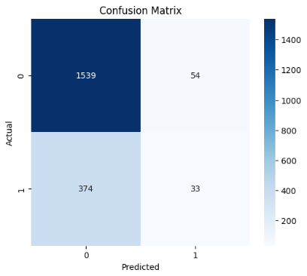
5.2 Improved Logistic Regression
Class‑Weighted Logistic Regression
To address class imbalance, a class‑weighted Logistic Regression model was used, where higher importance was assigned to the minority churn class during training.
- Recall improved to ~0.67
- Accuracy reduced to ~0.71
This improvement indicates that the model is now much better at identifying customers who are likely to churn. The reduction in accuracy reflects a trade‑off where some non‑churn predictions are sacrificed to significantly improve churn detection.
Benefit:
✅ Better alignment with business objectives
✅ Reduced bias toward majority class

SMOTE Model
Next, SMOTE (Synthetic Minority Oversampling Technique) was applied to generate synthetic churn samples and balance the training dataset.
- Balanced training data created
- Recall improved to ~0.66
- Accuracy remained around 0.71
SMOTE increases the model’s exposure to churn examples, allowing it to learn more representative decision boundaries. Similar performance to the class‑weighted model shows that resampling and cost‑sensitive learning are both effective for this dataset.

Tuned Model (GridSearchCV)
Finally, hyperparameter tuning was performed using GridSearchCV to optimize model performance.
Best parameters:
- C = 10
- Solver = saga
- class_weight = balanced
The tuned model achieved an AUC of approximately 0.74–0.75, indicating improved ability to distinguish between churners and non‑churners across different decision thresholds. Accuracy and recall remained consistent with the improved models.
Benefit of tuning:
✅ Better generalization
✅ Improved ranking performance (AUC)

5.3 Logistic Regression Summary
Model | Accuracy | Recall | AUC
Baseline | 0.786 | 0.524 | 0.734
Class-Weight | 0.709 | 0.695 | 0.737
SMOTE | 0.714 | 0.697 | 0.737
Tuned | 0.709 | 0.695 | 0.737

Overall, the baseline Logistic Regression model performs poorly for churn detection despite high accuracy. In contrast, the class‑weighted, SMOTE, and tuned models significantly improve recall, which is the most critical metric for churn prediction in this dataset. Although these improvements slightly reduce accuracy, they result in models that are far more effective for identifying customers at risk of leaving.
Improving recall is critical in churn prediction, and handling class imbalance greatly enhances the effectiveness of Logistic Regression on this dataset.

6. Model 2: Random Forest
The Random Forest algorithm is an ensemble learning method that constructs a multitude of decision trees during training and outputs the mode of the classes for classification tasks. It is highly effective in handling complex datasets with non-linear relationships and is robust against overfitting. This report presents a detailed analysis of four distinct Random Forest models developed for churn prediction. The dataset utilized for this study was partitioned into 75% for training, 15% for testing, and 10% for validation. The primary objective is to evaluate the impact of various techniques, such as hyperparameter tuning and class imbalance handling, on model performance.

6.1 Model Overview and Methodology
The development of the predictive models followed a systematic approach, beginning with a baseline model and progressively incorporating advanced techniques to address specific performance bottlenecks, particularly the challenge of class imbalance inherent in churn datasets.
Model 1: Baseline Random Forest
The initial model (Model 1) was implemented using the Random Forest algorithm with default parameters. Prior to training, the dataset underwent standard preprocessing steps, which included the imputation of missing values and the encoding of categorical variables. The primary goal of this baseline model was to establish a performance benchmark. While the model achieved a relatively high overall accuracy, it exhibited a significant deficiency in recall for the minority class (churned customers). This indicated that the model was biased towards the majority class and struggled to identify actual churn instances effectively.
Model 2: Class Weight Adjustment and Hyperparameter Tuning
To mitigate the poor recall observed in the baseline model, Model 2 incorporated techniques to handle class imbalance and optimize model parameters. The class_weight parameter was utilized to assign higher importance to the minority class during the training phase, thereby penalizing misclassifications of churned customers more heavily. Furthermore, hyperparameter tuning was conducted using GridSearchCV. This process involved testing multiple combinations of hyperparameters through cross-validation, with the optimal set selected based on the F1-score to ensure a balanced trade-off between precision and recall.
Model 3: Synthetic Minority Over-sampling Technique (SMOTE)
Model 3 explored an alternative approach to addressing class imbalance by applying the Synthetic Minority Over-sampling Technique (SMOTE). Instead of adjusting class weights, SMOTE generates synthetic samples for the minority class by interpolating between existing instances. This technique balances the class distribution in the training set, aiming to improve the model's ability to generalize and correctly identify churn cases without simply duplicating existing data points.
Model 4: SMOTE with Hyperparameter Tuning
The final model (Model 4) combined the data-level approach of SMOTE with the algorithm-level optimization of hyperparameter tuning. After balancing the dataset using SMOTE, GridSearchCV was employed to fine-tune the Random Forest hyperparameters, such as the number of estimators (trees) and the maximum depth of the trees. This comprehensive approach aimed to maximize the model's predictive capabilities by leveraging both a balanced training set and an optimized model architecture.

6.2 Results and Analysis
The performance of the four models was evaluated on the testing set (15% of the dataset) using standard classification metrics: Accuracy, Precision, Recall, and F1-Score. The results are summarized in Table 1 and visualized in Figure 1.
The performance of the four models was evaluated on the testing set (15% of the dataset) using standard classification metrics: Accuracy, Precision, Recall, and F1-Score. The results are summarized in Table 1 and visualized in Figure 1.
Model | Description | Accuracy | Precision | Recall | F1-Score
Model 1 | Baseline (Default Parameters) | 0.8093 | 0.6107 | 0.2540 | 0.3587
Model 2 | Class Weights + GridSearchCV | 0.7700 | 0.4479 | 0.5639 | 0.4993
Model 3 | SMOTE (Default Parameters) | 0.7260 | 0.3801 | 0.5508 | 0.4498
Model 4 | SMOTE + GridSearchCV | 0.7407 | 0.3929 | 0.5049 | 0.4419

Table 1: Performance metrics of the four Random Forest models on the test set.

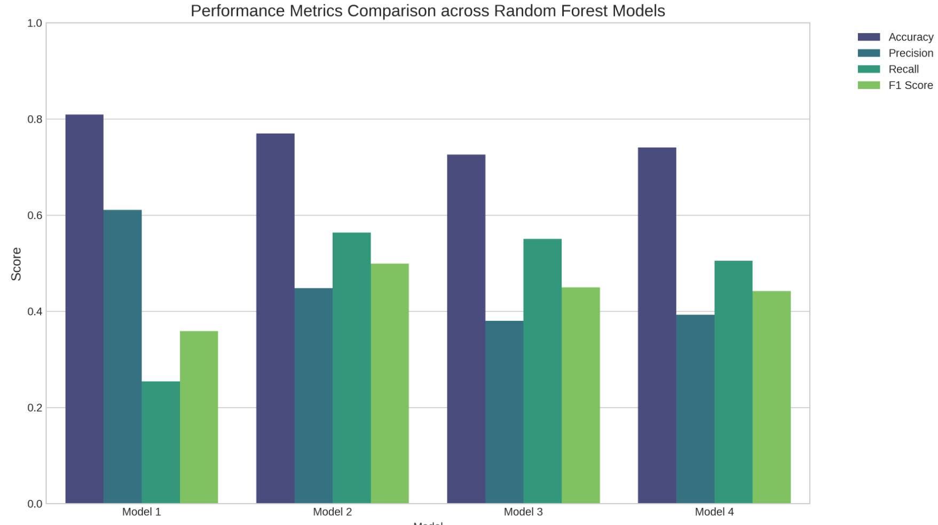
Figure 1: Bar chart comparing the performance metrics across the four Random Forest models.

6.3 Comparative Analysis
Model 1 achieved the highest accuracy (80.93%) and precision (61.07%) among all models. However, its recall was exceptionally low at 25.40%. In the context of churn prediction, a low recall means that the model fails to identify a large portion of customers who are actually going to churn. This renders the high accuracy misleading, as it is primarily driven by the correct classification of the majority class (non-churners). The resulting F1-score of 0.3587 reflects this severe imbalance between precision and recall.
Model 2 demonstrated a significant improvement in identifying churners, with recall increasing to 56.39%. This improvement was achieved through the application of class weights and hyperparameter tuning. While accuracy (77.00%) and precision (44.79%) decreased compared to the baseline, the F1-score reached its highest value across all models at 0.4993. This indicates that Model 2 provides the most balanced performance, effectively trading off some precision for a substantial gain in recall, which is crucial for proactive retention efforts.
Model 3, which utilized SMOTE to balance the dataset, also showed improved recall (55.08%) compared to the baseline. However, it resulted in the lowest accuracy (72.60%) and precision (38.01%). The F1-score (0.4498) was lower than that of Model 2, suggesting that while SMOTE helped the model recognize the minority class, it also introduced a higher rate of false positives (predicting churn when the customer does not churn).
Model 4 attempted to refine the SMOTE approach by adding hyperparameter tuning. This resulted in slight improvements in accuracy (74.07%) and precision (39.29%) over Model 3, but at the cost of a reduced recall (50.49%). The F1-score (0.4419) remained lower than that of Model 2. This suggests that for this specific dataset, algorithmic adjustments (class weights) combined with tuning were more effective than data-level oversampling (SMOTE) combined with tuning.
Confusion Matrix Analysis
To further illustrate the impact of addressing class imbalance, we can examine the confusion matrices. Figure 2 presents confusion matrices comparing the baseline model (Model 1) with the best-performing balanced model (Model 2)
The confusion matrix for Model 1 clearly shows a high number of True Negatives (correctly predicted non-churners) but a disproportionately high number of False Negatives (actual churners predicted as non-churners). This visualizes the low recall issue, where the model misses many churn events.

Conversely, the confusion matrix for Model 2 demonstrates a shift. The number of True Positives (correctly predicted churners) increases significantly, reflecting the improved recall. However, this comes at the expense of an increased number of False Positives (non-churners incorrectly predicted as churners), which explains the drop in precision. In a business context, this trade-off is often acceptable, as the cost of missing a churning customer (False Negative) is typically higher than the cost of unnecessarily targeting a retained customer with a retention campaign (False Positive).

7. Model Comparison

Student Interpretation
- Logistic Regression:
  - Better at detecting churners (high recall)
  - But less accurate overall
- Random Forest:
  - Better overall performance (accuracy + AUC)
  - More stable predictions
👉 Final insight:
Logistic Regression is useful for interpretability, while Random Forest provides better predictive performance.

8. ROC Curve Analysis
- Logistic Regression AUC: ~0.73–0.75
- Random Forest AUC: ~0.85
👉 Random Forest curve is closer to top-left → better model

9. Discussion

Why Random Forest performed better
- Captures non-linear patterns
- Handles feature interactions
- Less affected by scaling issues

Limitations
- Logistic Regression:
  - Cannot model complex relationships
- Random Forest:
  - Less interpretable
  - More computationally expensive

10. Future Work
- Try advanced models:
  - Gradient Boosting (XGBoost)
- Feature engineering:
  - Create new variables
- Threshold tuning:
  - Optimize recall vs precision
- Ensemble methods

11. Conclusion
This project compared two machine learning models for churn prediction:
- Logistic Regression provided a strong baseline and high recall after improvements
- Random Forest achieved higher overall accuracy and AUC
👉 Final conclusion:
Random Forest is the better performing model for this dataset, while Logistic Regression remains valuable for interpretability and baseline comparison.

12. Compliance with Assignment Requirements
- Used only Machine Learning algorithms ✅
- No Deep Learning models used ✅
- Applied two distinct supervised algorithms ✅
- Included preprocessing, evaluation, and comparison ✅

13. Appendix
- Full code available in:
  - Logistic Regression Notebook
  - Random Forest Notebook

14. Individual Contribution (Example)
- Member 1: Data preprocessing, EDA
- Member 2: Model development, evaluation, comparison

15. References
- UCI Machine Learning Repository
- Kaggle Dataset
- Scikit-learn Documentation

